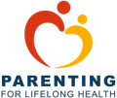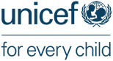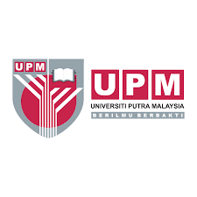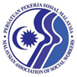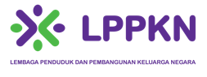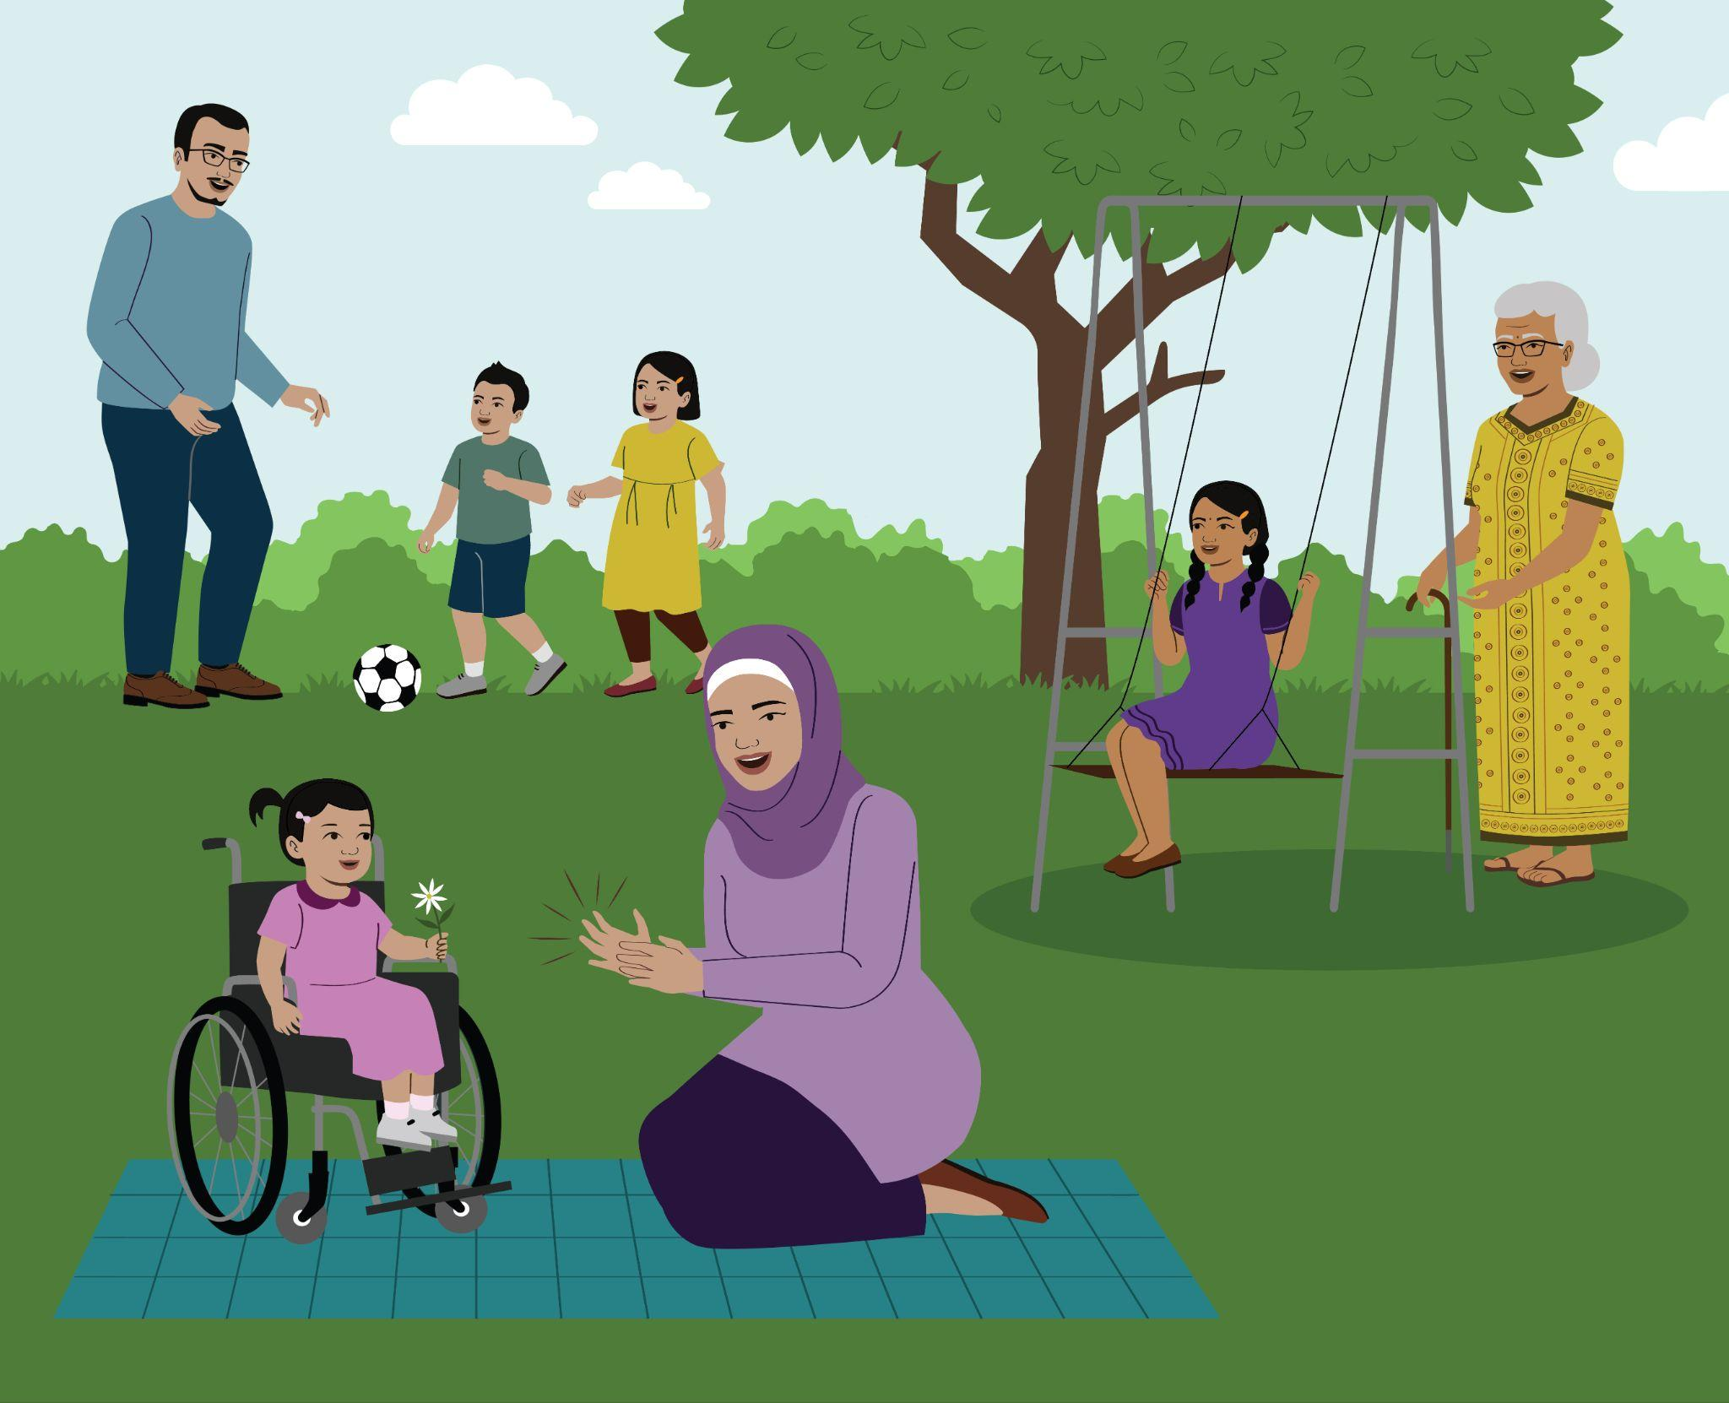**Program Keibubapaan Positif Hibrid Naungan Kasih – Manual Fasilitator**

EDISI PERTAMA OKTOBER 2023

The Naungan Kasih Hybrid Positive Parenting Programme was developed in collaboration with the Malaysian National Population and Family Development Board (LPPKN) in the Ministry of Women, Family, the Community Development Department (KEMAS) in the Ministry of Rural Development, UNICEF Malaysia, the Malaysian Association of Social Workers (MASW), the Universiti Putra Malaysia (UPM), University of Oxford, IDEMS International, and Parenting for Lifelong Health.

License for the Naungan Kasih Positive Parenting Programme is held by UNICEF Malaysia and the original authors via Creative via a Commons Attribution-NoDerivatives and NonCommercial 4.0 International Public License. Except where otherwise noted, this work is licensed under Creative Commons.



The conditions of the License including the following:

* ATTRIBUTION: Appropriate credit must be given when using the Naungan Kasih Hybrid Parenting Programme according to the Creative Commons definition, including (a) the name of the authors and attribution parties, (b) a copyright notice, (c) a license notice, (d) a disclaimer notice, and (e) a link to the material.
* NON-COMMERCIAL: The Naungan Kasih Hybrid Parenting Programme materials are to be made available free of charge.
* NO DERIVATIVES: No changes to any Licensed Materials are allowed without prior approval. The License is applicable to any changes, adaptation, or translations of Licensed materials;

Any deviation of the terms of the License is strictly prohibited.

## Acknowledgements

The Naungan Kasih Hybrid Parenting Programme was informed by recommendations from the Naungan Kasih Positive Parenting Programme and the assessment of the Belaian Kasih (young children from birth to 13 years of age) and Mutiara Kasih (adolescent) parenting training modules for parents and caregivers in Malaysia, as well as analysis of learning from evidence-based parenting programmes and current best practice, such as described by Frances Gardner in the UNICEF Innocenti Research Brief 2017-10 and UNICEF and the WHO’s Seven Strategies to End Violence Against Children in low- and middle-income countries. The two Malaysian parenting modules were developed by National Population and Family Development Board (LPPKN).

The structure and content of this current programme were also drawn and adapted from the following key resource materials:

* Lachman J.M. & Hutchings J. (2018). Parenting for Lifelong Health Programme for Young Children – European Version. Facilitator Manual. Fifth Edition
* Lachman J.N. & Hutchings J. (2017). Parenting for Lifelong Health Programme for Young Children. Parent Handbook. Fourth Edition
* Doubt J., Tsoanyane S., Lachman J.M., Ward C. & Cluver L. (2015). Sinovuyo Caring Families Programme for Parents and Teens. Facilitator Manual. Parenting for Lifelong Health for Teens. Third Edition
* Doubt J., Tsoanyane S., Lachman J.M., Ward C. & Cluver L. (2016). Sinovuyo Caring Families Programme for Parents and Teens. Family Guidebook. Parenting for Lifelong Health for Teens. First Edition
* Landers C. (2005). Parenting with Confidence: Enhancing the Development of Young Children. A Guide for Parent Facilitators. International Step by Step Association
* UNICEF & WHO (2012). Care for Child Development: Improving the Care of Young Children
* Coordinating Comprehensive Care for Children (4Children) Nigeria (2018). Better Parenting Facilitator Manual
* Long S. & Stuer F. (2018). Training Course for Auxiliary Social Workers. HIV- Sensitive Child Protection
* Key findings of formative evaluation study conducted by Maestral International and the Universiti Putra Malaysia from March to June 2018